King County

Iris Society

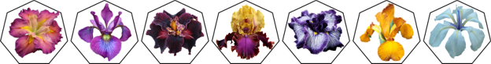

Beardless Iris Sale

Saturday, September 19, 2015

Crossroads Bellevue

15600 NE 8th Street

Bellevue, WA 98008

Open to Public

10:00am to 3:00pm

Visit www.kcis.org for details

King County

Iris Society



Beardless Iris Sale

Saturday, September 19, 2015

Crossroads Bellevue

15600 NE 8th Street

Bellevue, WA 98008

Open to Public

10:00am to 3:00pm

Visit www.kcis.org for details